SimplyHosted – User Guide

| www.cqsimple.com

General Phone Usage

This guide will focus on the usage of CQ 50 Series phones. Other phones certainly will work on the SimplyHosted platform but the directions associated with some functions, such as transferring or parking a call will differ.

- Placing a Call

  - Dial the number on the keypad and pickup the handset.
  - Dial the number on the keypad and press the speaker button.
  - Pick up the handset, dial the number and press Send.

- End a Call
  - Press the Cancel button on the screen
  - Hang up the handset

- Place a call on hold.
  - Placing a call on hold keeps the caller on your phone only. No other extension can pickup that caller.
  - During a conversation press the Hold key on the screen.
  - During a conversation press the Hold key that is located at the button of the phone. It has a handset and pause sign on it.
  - To pick up a call on hold pres the resume key on the screen or press the Hold key again.

- Conference in another caller
  - Press the Conference button on the phone
  - Dial the number of the person you wish to conference in and press Send
  - When the person picks up you can press the Conf button to bridge the callers and yourself together.

- Park a Call
  - Parking a call allows other extensions to pick up the parked call without having to transfer the call to a specific extension.
  - During a conversation press your Park key.
  - If no one picks up the call within a set amount of time the call will ring back to your phone. If you are on the phone when the call comes back to you it will go to a failover destination. Both the amount of time a caller can stay on park and the failover destination can be changed by your phone administrator.

- Pickup a Parked Call
  - Press the BLF key on your phone that is programmed as that parking lot. If someone is parked in that lot the key should be red. When you pick up that call the key will turn green.
  - If you have a Parking Lots key you should see the Parking Lots key turn red. If you press the Parking Lots key you should see all of the calls that are parked and you can navigate to the call you wish to pick up.

- Transfer a Call
  - In firmware 2.0.4.6.20 and above you can simply press the BLF key of the extension you wish to transfer a caller to.
  - Press the transfer key on your screen, dial the extension you wish to transfer the call, and then press B Transfer.
  - For an attended transfer, meaning you want to speak to your colleague before you send them a call – Press transfer, dial the extension, speak to your colleague and then either hang up or press the transfer key on your phone when they are ready.

- Transfer a call directly to Voicemail
  - Press the transfer key on your screen, then press the blind key on your phone, dial *extension you wish to transfer the call to and then press Send.
  - Transfer *200 B Transfer will transfer a call directly to 200’s Voicemail
  - If your system has been updated and the backend programming made then you can press and hold a BLF key for another user and it will go directly to their VM box. (Does require dealer programming)

- To check your Voicemail
  - Dial *97 (press send) and then enter your VM password when prompted. Your setup may not require a password when dialing VM from your phone.
  - Default VM passwords are typically you extension number but check with your phone admin if this is not working.
  - Press the Mailbox key on the far left of your phone (Envelope), select the account you wish to access and press Connect.

- To check the Voicemail of any extension
  - Dial *98 (Send) and then enter the VM box you wish to access.

- Setting up Initial VM and Greetings
  - The first time you log into your VM box the system will walk you through recording your greetings

- Changing your VM Greetings after your initial setup
  - Dial *97 to access your VM
  - Dial 0 to go to the Mailbox Options Section.
    - From there you can dial one of the Following:
    - 1 Record Unavailable Message
    - 2 Record Busy Message
    - 3 Record your Name
    - 4 Manage your Temporary Greeting
    - -When you record your temporary greeting it will become the dominate message played when anyone calls your phone. When you come back, from vacation for example, you must delete that message for the phone to revert back to using your original messages.
    - 5 Change Password

- Mute your phone
  - Press the Mute button on the far left of your phone (Microphone with a slash through it)

Phone Customization

- To change the button on your CQ phone (You cannot change the 4 buttons on the bottom of the screen)
  - Press the check mark on the upper right of your phone twice. Make note of the IPV4 Address.
    - Open the web browser of your choice (Chrome preferred)
    - Type in the Address such as 192.168.1.13
    - Default username and password are admin
    - Select Function Keys on the top menu to change the keys of your choice.
***If you want to change your own buttons please contact your phone admin to allow your settings to stay. Otherwise your phone will revert to the original template it was delivered with***

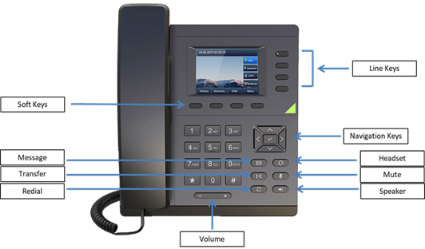

Mute

Voicemail

Volume

Headset

Transfer

Speaker

